BIOS6621-Homework8-Randy

Randy

11/19/2019

#### Question1

Alfuzo <- c(1,1,2,2,3,1,0,3,3,2,5,2,1,3,2,1,1,2,1,2,2,2,2,1,1,5,1,2,3,1,2,5,1,5,3,3,3,2,5,2,3,4,3,4,5,3,4,3,2,3,5,2,2,3)  
NonAlfuzo <- c(10, 7, 4, 4, 3, 5, 6, 7, 7, 3, 5, 2, 4, 4, 6, 3, 6, 2, 5, 3, 5, 2, 4, 2, 3, 6, 4, 5, 4, 7, 4, 3, 3, 4, 2, 4, 4,3)  
  
hist(Alfuzo, main = "Alfuzosin")

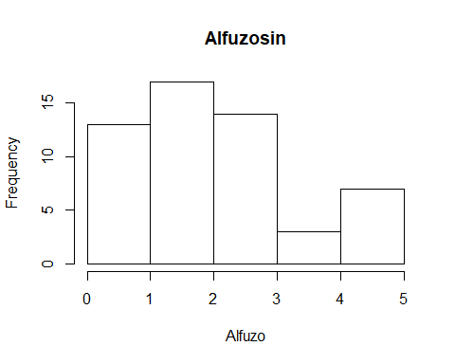

hist(NonAlfuzo, main = "Off Alfuzosin")

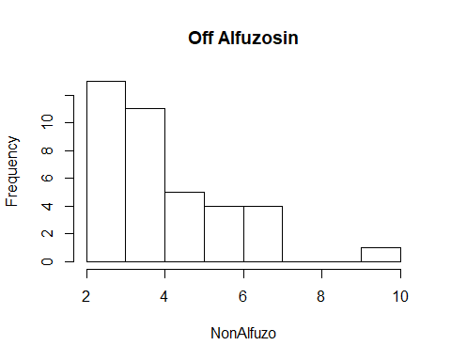

par(mfrow=c(1, 2))  
boxplot(Alfuzo, main = "Alfuzosin")  
boxplot(NonAlfuzo, main = "Off Alfuzosin")

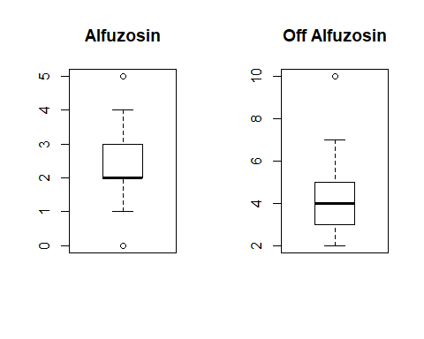

wilcox.test(Alfuzo, NonAlfuzo)

##   
## Wilcoxon rank sum test with continuity correction  
##   
## data: Alfuzo and NonAlfuzo  
## W = 409.5, p-value = 6.577e-07  
## alternative hypothesis: true location shift is not equal to 0

Both distributions are not normal and right skewed. There is also outlier in the “Non-Alfuzosin” group. Hence the nonparametric test would be appropriate. The Wilcoxon Rank Sum Test provides a p-value that is <0.05; this result shows that there is a statistically signifiant difference between the groups of Alfuzosin and Non-Alfuzosin. We need to consider the side effects besides make decisions about whether actually use Alfuzosin.